Student Records Management System
System Design Specification (SDS)
Prepared for Module 3 Final Project Launch
1. Purpose
The purpose of this system is to provide a simple and user-friendly way to store, manage, and update student information. The system will allow users to enter, edit, and delete student records, and to review academic information such as GPA and eligibility for honors such as the Dean’s List or Honor Roll.
2. Scope
This project will develop a Python-based Student Records Management System with a graphical user interface (GUI). The system will support basic CRUD operations—Create, Read, Update, and Delete student records. The project will use object-oriented programming principles and Python collections such as lists and dictionaries to manage data. To keep the project realistic and achievable within the course timeline, the system will not use an external database and will instead store data in memory during execution.
3. Client and System Users
The intended client for this system is a school or academic department that needs a simple application to manage student records. The primary users of the system will be staff members or administrators who need to maintain student information efficiently.

4. Functional Requirements
• Add new student records
• Display existing student records
• Update student information
• Delete student records
• Identify honors eligibility based on GPA
• Provide a graphical user interface for user interaction
- Search certain student based on name
- Filtering students with GPA >=3.5
5. System Design
The system will follow object-oriented programming principles and include at least three main classes:
Class | Purpose
Student | Stores individual student information such as first name, last name, student ID, and GPA.
StudentManager | Manages the collection of student records and performs CRUD operations.
MainProgram / GUI | Handles user interaction through the graphical interface.

6. Data Structures
The project will use collections such as lists and dictionaries to store and organize student information during program execution.
7. User Interface
The system will include a user-friendly graphical interface that allows the user to add, view, update, and delete student information in a simple and efficient manner.
8. UML Diagram
I have uploaded the UML class diagram for the Student Records Management System below. The diagram shows the main classes used in the system, including Student, StudentManager, and MainProgram/GUI, along with their relationships and responsibilities.
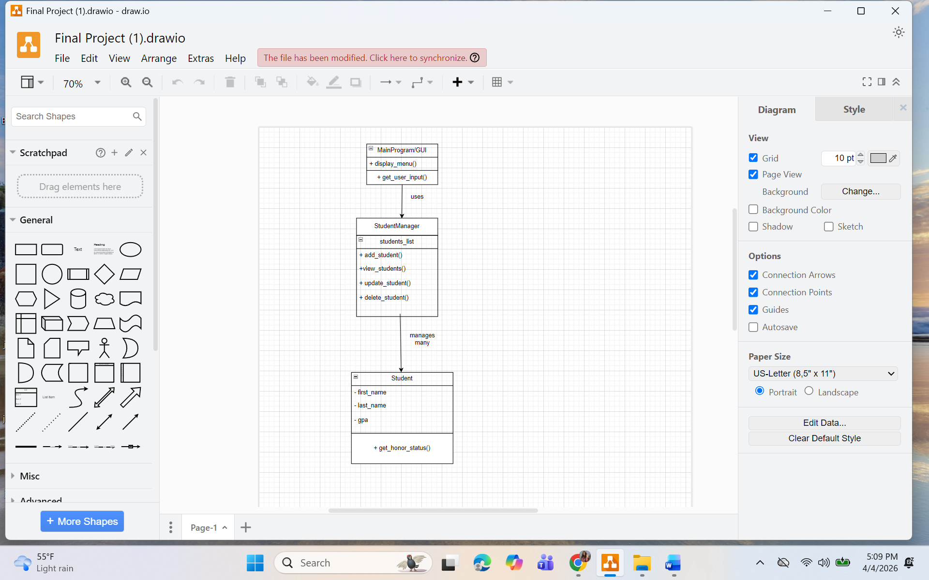
9. Communication Plan
The team will communicate using GroupMe for updates, reminders, and quick questions. Team members will check in at least once per week to discuss progress, assign tasks, and resolve issues. GitHub will be used for code sharing and version control, and Google Drive and Google Docs for shared project documents.

10. Team Roles
Team Member | Role and Responsibility
Alex Jolliff | Project Manager — oversees team progress, coordinates tasks, and helps ensure requirements are completed.
Barsha Bhandari | Developer, Designer, and Documentation Lead — created the UML diagram, prepared the SDS, contributed to class design, and organized documentation.
Yifeng Hu | Second Developer, Designer – review the project, testing, debugging, adding additional features, contributed to class design
Other Team Member(s) | Development, testing, debugging, GUI implementation, and review.

